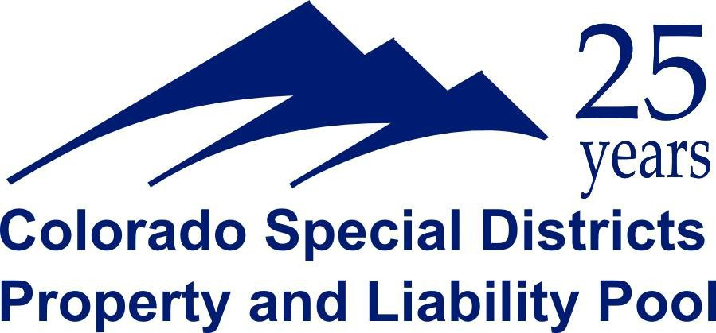

COLORADO GOVERNMENTAL IMMUNITY

HISTORICAL BASIS:
Prior to 1973, public entities in Colorado were protected by sovereign immunity which was common law.

1973 Colorado Supreme Court abolished common law doctrine of sovereign immunity and declared any immunity would thereafter come from legislated immunity only. The State Legislature then passed the Governmental Immunity Act (GIA) which applies to all public entities in the State.

SUMMARY:
State law immunities for a public entity and public employee are governed by the terms of the Colorado Governmental Immunity Act, §24-10-101, C.R.S.

Generally a public entity or public employee is immune from liability in all claims for injury which lie in tort or could lie in tort except when specifically waived. Under the Act, at §106, there are six specifically denominated exceptions to waiver.

WAIVER OF IMMUNITY UNDER THE ACT:

- Operation of an owned or leased motor vehicle.
- Operation of any public hospital, correctional facility or jail.
- Dangerous condition of any public building.
- Dangerous condition of a public highway, road or street (within certain defined limits).
- Dangerous condition of any public hospital, jail, public facility located in any park, recreation area maintained by a public entity, or public water, gas, sanitation, electrical, power or swimming facility.
- Operation and maintenance of any public water, gas sanitation, electrical or swimming facility.

LIMITATION OF JUDGEMENTS OF THE ACT:
In the six areas of waived immunity, the Act limits the amount of judgments that can be recovered from any public entity and/or a public employee to:
  - $350,000 for any injury to one person in any single occurrence;
  - $990,000 for any injury to two or more persons in any single occurrence; except that, in such instance, no person may recover in excess of $350,000.

Prior to July 1, 2103, the limits were $150,000 for any injury to one person in any single occurrence and
$600,000 for any injury to two or more persons in any single occurrence, except that, in such instance, no person may recover in excess of $150,000.

EMPLOYEES AND AUTHORIZED VOLUNTEERS:
Paid Employees are provided the same protections of the Governmental Immunity Act as is provided to the Public Entity. This applies to all classes of paid employees.

McGriff, Seibels & Williams of Oregon, Inc.

Additionally, "authorized volunteers" also enjoy the protections of the Governmental Immunity Act as long as functions or operations performed are for the benefit of the Public Entity, at the request of the Public Entity and subject to the control of the Public Entity.
Students participating in service activities that are required for completion of a course and/or are required for obtaining a degree (including internships and work exposure programs) are considered "authorized volunteers" and are provided the protections of the Governmental Immunity Act.

EXCLUSION OF PROTECTION:

No individual is provided liability protection for acts that are outside the scope of assigned duties or that are willful and wanton, intentional, or criminal in nature.
No protection for Independent Contractors or any person who is sentenced to participate in any type of useful public service
No protection for federal claims.

This summary is only a synopsis of the Colorado Governmental Immunity Act, §24-10-101, C.R.S. That has been prepared for the convenience of Colorado Special Districts. Actual language of the Act must be consulted for any definitive evaluation of terms and conditions of the Act.

